Siddharth Rane

11/4/19

Course: Physics 208

Section: ST5

Lab #4: Electric Potential

This lab will find the electric field of a system by measuring the electric potential. Electric potential tells us if a charge wants to move or not. Knowing the electric potential of the system tells us how the electrons will behave in that system. This electric potential is related to the electric field of the system. Electric field can be represented by the following relationship:

Where is the electric field in the x-direction, is the change in potential and is the change in position. Overall, this formula states that the electric field is equal to the negative of the rate of change of the potential as a function of position.

Procedure:

Before we start the lab, we gather the necessary tools and devices such as a ring setup, a ruler and a multimeter. We need to find the field by measuring the potential by making sure the rings are not connected to power. We need to measure the outer radius and inner radius or the small rings. We then connect the 0V blue wire to the inner ring using the electrode. The 5V brown wires is connected to the outer ring via the electrode. Take the cable and plug it into the wall socket. The real experiment is like the virtual experiments that were conducted. There will be two charged rings placed above a piece of paper. The smaller of the rings will be placed inside the larger ring so that they share the same center. We need to find the electric field of this system, but first we must find different potentials at different points. This will be done using a multimeter and pointing it at different points between the inner ring and the outer ring. After recording this data, we would also need to record the inner radius and the outer radius. Once we have all this data, we can make the necessary calculations to find the electric field.

Questions and Data:

|  |  |
| --- | --- |
| **Position (m)** | **Electric Potential (V)** |
| 0.01 | 0.7 |
| 0.02 | 1.4 |
| 0.03 | 2.1 |
| 0.04 | 2.8 |
| 0.05 | 3.5 |
| 0.06 | 4.2 |
| 0.07 | 4.9 |
| 0.08 | 5.6 |
| 0.09 | 6.3 |
| 0.1 | 7.0 |

**Graph 1: Position(m) vs. Electric Potential(V) – Parallel Plates**

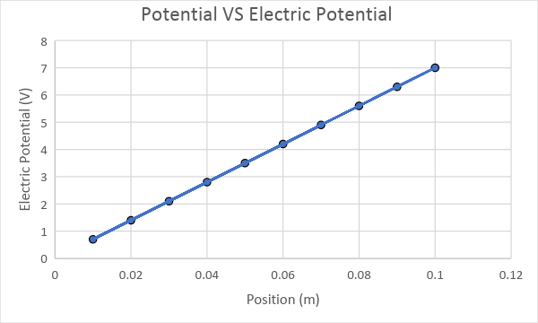

**Table 2: Virtual Measurement 2**

|  |  |
| --- | --- |
| **Radius (m)** | **Electric Potential (V)** |
| 0.01 | 0.2 |
| 0.02 | 0.1 |
| 0.03 | 0.067 |
| 0.04 | 0.05 |
| 0.05 | 0.04 |
| 0.06 | 0.033 |

**Graph 2: Radius(m) vs. Electric Potential(V) – Point Charge**

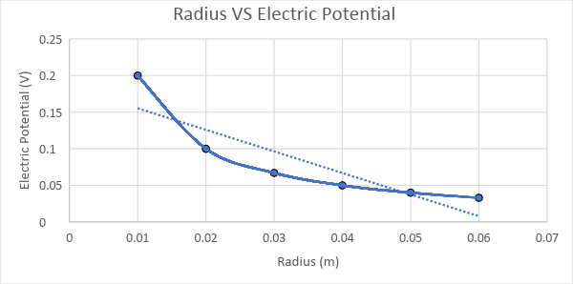

**EXPERIMENT 2:**

For this experiment, the measurement of the radius of the inner ring and the outer ring was taken using a ruler. Next, voltage at different points on the board, in between the rings was taken using a multimeter. This was done three times at three different places in between the rings. To find the potential difference values, average of the values was calculated.

|  |  |  |  |  |
| --- | --- | --- | --- | --- |
| **Position r(m)** | **Voltage 1(V)** | **Voltage 2(V)** | **Voltage 3(V)** | **Voltage avg(V)** |
| 0.005 | 1.4 | 1.4 | 1.7 | 1.4 |
| 0.01 | 1.8 | 1.9 | 2 | 1.9 |
| 0.015 | 2.3 | 2.3 | 2.3 | 2.3 |
| 0.02 | 2.65 | 2.7 | 2.7 | 2.68 |
| 0.025 | 3 | 3 | 3 | 3 |

**REPORT QUESTIONS:**

1. Prepare a plot of your Potential vs. Position data using the averages for the voltage measurements at various positions. It should resemble a log function.

**Answer. Graph 3: Position (m) vs. Average Voltage (V)**

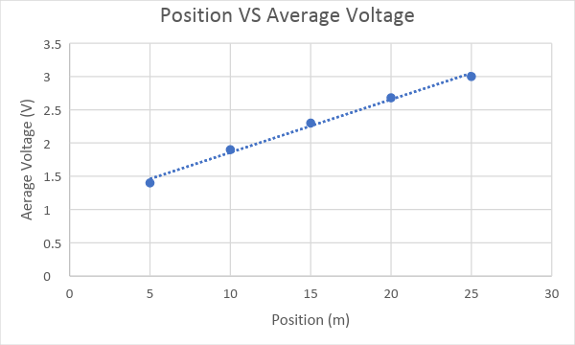

1. Plot V vs. ln(r). This should be a straight line.

**Answer. Graph 4: Position ln(r) (m) vs. Average Voltage (V)**

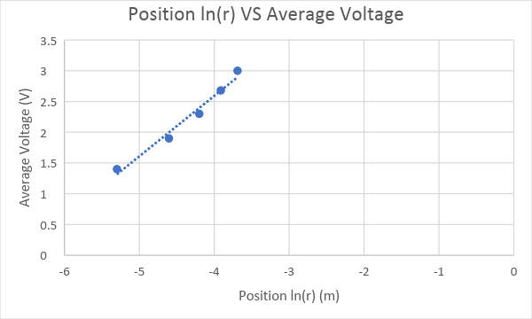

1. Use the above to establish a value for the constant A. What units should it have?

**Answer.** The slope from graph 4 above is A= 0.9818. The value of A does not have a unit. It is a constant value.

1. Use equation (1) and (2) to obtain an expression for the electric field.

**Answer.**

Conclusion:

In conclusion, it can be said that the data collected from the experiments correlated with the relationships of an electric field and the movements of the charge. The charges of the inner and the outer rings are opposite because if the potential difference readings are negative and negatively increasing as the radius increasing, then the inner ring has negative charge and the outer ring has positive charge. The reasons behind finding inaccurate measurements could be fault in the board, where the rings were placed. Also, having a defaulted multimeter, or choosing improper ground. During our experiment, ring set up board had many tiny holes, which made it hard to select a position for measuring the voltage. Also, our multimeter stopped reading values in the middle of performing second experiment. We tried to troubleshoot the system by checking the connecting of the board, but it still was not working. I think using better equipment can provide more accurate data during the experiments.